1. Copy place_order.py to place_order2.py
   1. We will be using place_order.py in future labs. Hence, let’s modify a copy.
2. Edit place_order2.py to **first** do a check that the **books’ availability is more than the quantity ordered**.
   1. If any of the ordered book’s availability is less than quantity ordered, return error.
   2. There is no need to write to the activity log, activate error, etc.
   3. Otherwise, continue as described in the lab.

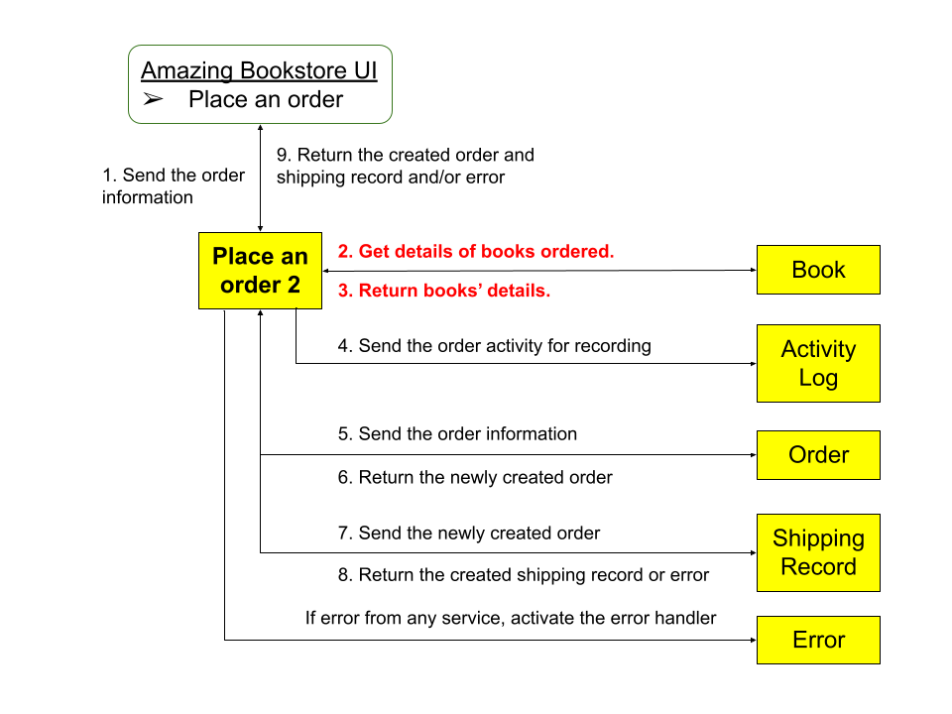

Suggested response.

| Code - 409 | Description – insufficient books in stock  {  "code": 409,  "data": [  {  "availability": 5,  "isbn": "9213213213213",  "required": 1000  },  {  "availability": 2,  "isbn": "9781449474212",  "required": 987  }  ],  "message": "Insufficient books in stock."  } |
| --- | --- |